Git and Github
Let’s start with the basics. Git is a version control system that allows you to track changes to your files and collaborate with others. It is used to manage the history of your code and to merge changes from different branches. I can understand that as of now these terms like version control, branches, and merges are not familiar to you. But don’t worry, we will learn them in this tutorial.

Git and Github are different
Git is a version control system that is used to track changes to your files. It is a free and open-source software that is available for Windows, macOS, and Linux. Remember, GIT is a software and can be installed on your computer.
Github is a web-based hosting service for Git repositories. Github is an online platform that allows you to store and share your code with others. It is a popular platform for developers to collaborate on projects and to share code. It is not that Github is the only provider of Git repositories, but it is one of the most popular ones.
A little on version control systems
Version control systems are used to manage the history of your code. They allow you to track changes to your files and to collaborate with others. Version control systems are essential for software development. Consider version control as a checkpoint in game. You can move to any time in the game and you can always go back to the previous checkpoint. This is the same concept in software development.
Before Git became mainstream, version control systems were used by developers to manage their code. They were called SCCS (Source Code Control System). SCCS was a proprietary software that was used to manage the history of code. It was expensive and not very user-friendly. Git was created to replace SCCS and to make version control more accessible and user-friendly. Some commong version control systems are Subversion (SVN), CVS, and Perforce.
Learning Path
In this tutorial, we will learn the basics of Git and Github. We will start with the basics and then move on to more advanced topics. We will also learn how to use Git and Github for collaboration and version control. By the end of this tutorial, you will have a good understanding of Git and Github and will be able to use them to manage your code effectively.
We will go in this jounney something like this:
- Get the basics
- Use it daily
- Face the problems
- Solve them
- Learn more
We will focus more on Git first, once you understand git, moving towards Github will be easy.
Install Git
To install Git, you can use command line or you can visit official website and download the installer for your operating system. Git is available for Windows, macOS, and Linux and is available at https://git-scm.com/downloads.
Account on Github
Another step that you have to follow is to create an account on Github. I will later walk you through the process of linking your Github account with your Machine. You cannot push your code to Github without ssh-key setup. Password authentication is not recommended and these days it is not possible to use it. So, you need to setup ssh-key authentication. We will cover that in a later part of the tutorial.
Conclusion
In this part, we have learned the basics of Git and Github. We have also learned how to install Git and Github. We have also learned about the importance of version control systems and how they are used in software development. By the end of this tutorial, you will have a good understanding of Git and Github and will be able to use them to manage your code effectively.

Terminology
Git and people who use it talk in a different terminology. For example they don’t call it a folder, they call it a repository. They don’t call it alternative timeline, they call it branch. Although, I agree that alternative timeline is a better name for it.

Check your git version
To check your git version, you can run the following command:
Terminal window
git --version
This command will display the version of git installed on your system. Git is a very stable software and don’t get any breaking changes in majority of the cases, at least in my experience.

Repository
A repository is a collection of files and directories that are stored together. It is a way to store and manage your code. A repository is like a folder on your computer, but it is more than just a folder. It can contain other files, folders, and even other repositories. You can think of a repository as a container that holds all your code.
There is a difference between a software on your system vs tracking a particular folder on your system. At any point you can run the following command to see the current state of your repository:
Terminal window
git status

Your config settings
Github has a lot of settings that you can change. You can change your username, email, and other settings. Whenever you checkpoint your changes, git will add some information about your such as your username and email to the commit. There is a git config file that stores all the settings that you have changed. You can make settings like what editor you would like to use etc. There are some global settings and some repository specific settings.
Let’s setup your email and username in this config file. I would recommend you to create an account on github and then use the email and username that you have created.
Terminal window
git config --global user.email "your-email@example.com"
git config --global user.name "Your Name"
Now you can check your config settings:
Terminal window
git config --list
This will show you all the settings that you have changed.

Creating a repository
Creating a repository is a process of creating a new folder on your system and initializing it as a git repository. It’s just regular folder to code your project, you are just asking git to track it. To create a repository, you can use the following command:
Terminal window
git status
git init
git status command will show you the current state of your repository. git init command will create a new folder on your system and initialize it as a git repository. This adds a hidden .git folder to your project.
Commit
commit is a way to save your changes to your repository. It is a way to record your changes and make them permanent. You can think of a commit as a snapshot of your code at a particular point in time. When you commit your changes, you are telling git to save them in a permanent way. This way, you can always go back to that point in time and see what you changed.
Usual flow looks like this:
Write Add Commit

Complete git flow
A complete git flow, along with pushing the code to github looks like this:

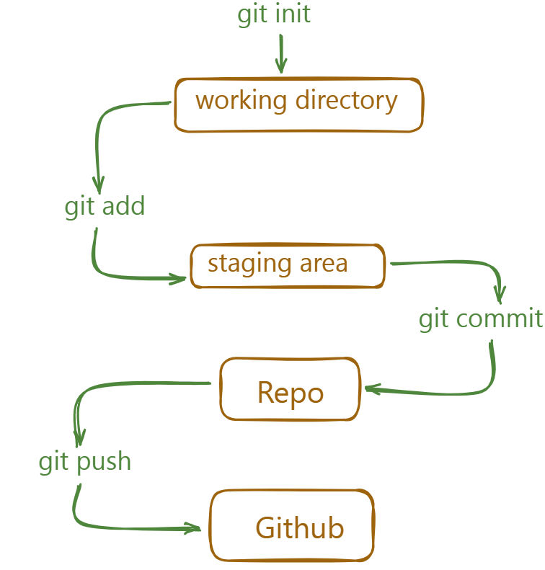

When you want to track a new folder, you first use init command to create a new repository. Then you can use add command to add the folder to the repository. After that you can use commit command to save the changes. Finally you can use push command to push the changes to github. Of course there is more to it but this is the basic flow.
Stage
Stage is a way to tell git to track a particular file or folder. You can use the following command to stage a file:
Terminal window
git init
git add <file> <file2>
git status
Here we are initializing the repository and adding a file to the repository. Then we can see that the file is now being tracked by git. Currently our files are in staging area, this means that we have not yet committed the changes but are ready to be committed.
Commit
Terminal window
git commit -m "commit message"
git status
Here we are committing the changes to the repository. We can see that the changes are now committed to the repository. The -m flag is used to add a message to the commit. This message is a short description of the changes that were made. You can use this message to remember what the changes were. Missing the -m flag will result in an action that opens your default settings editor, which is usually VIM. We will change this to vscode in the next section.
Logs
Terminal window
git log
This command will show you the history of your repository. It will show you all the commits that were made to the repository. You can use the --oneline flag to show only the commit message. This will make the output more compact and easier to read.
☕️ - Check git log docs
Atomic commits are a way to make sure that each commit is a self-contained unit of work. This means that if one commit fails, you can always go back to a previous commit and fix the issue. This is important for maintaining a clean and organized history in your repository.
change default code editor
You can change the default code editor in your system to vscode. To do this, you can use the following command:
Terminal window
git config --global core.editor "code --wait"
gitignore
Gitignore is a file that tells git which files and folders to ignore. It is a way to prevent git from tracking certain files or folders. You can create a gitignore file and add list of files and folders to ignore by using the following command:
Example:
node_modules
.env
.vscode
Now, when you run the git status command, it will not show the node_modules and .vscode folders as being tracked by git.
Conclusion
In this section, we have learned about the basics of git and how to use it to track changes to your files and folders. We have also learned about the different commands that you can use to interact with your repository, such as init, add, commit, log, etc By the end of this section, you should have a good understanding of how to use git and how to use it effectively to manage your code.

Git behind the scenes:
Git is a version control system that allows you to track changes to your files and folders. It is a powerful tool that can help you manage your code more effectively. In this section, we will explore the basics of how git works internally.
Git Snapshots
A git snapshot is a point in time in the history of your code. It represents a specific version of your code, including all the files and folders that were present at that time. Each snapshot is identified by a unique hash code, which is a string of characters that represents the contents of the snapshot.
A snapshot is not an image, it’s just a representation of the code at a specific point in time. Snapshot is a loose term that is used when git stores information about the code in a locally stored key-value based database. Everything is stored as an object and each object is identified by a unique hash code.
3 Musketeers of git
The three musketeers of git are:
- Commit Object
- Tree Object
- Blob Object
Commit Object
Each commit in the project is stored in .git folder in the form of a commit object. A commit object contains the following information:
- Tree Object
- Parent Commit Object
- Author
- Committer
- Commit Message
Tree Object
Tree Object is a container for all the files and folders in the project. It contains the following information:
- File Mode
- File Name
- File Hash
- Parent Tree Object
Everything is stored as key-value pairs in the tree object. The key is the file name and the value is the file hash.
Blob Object
Blob Object is present in the tree object and contains the actual file content. This is the place where the file content is stored.
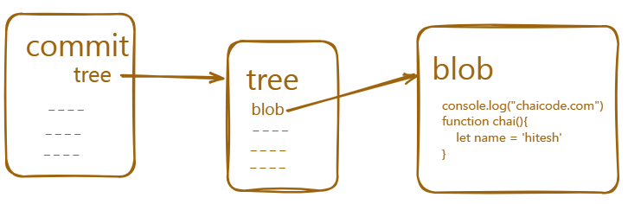

Helpfil commands
Here are some helpful commands that you can use to explore the git internals:
Terminal window
git show -s --pretty=raw <commit-hash>
Grab tree id from the above command and use it in the following command to get the tree object:
Terminal window
git ls-tree <tree-id>
Grab tree id from the above command and use it in the following command to get the blob object:
Terminal window
git show <blob-id>
Grab tree id from the above command and use it in the following command to get the commit object:
Terminal window
git cat-file -p <commit-id>

Branches in git
Branches are a way to work on different versions of a project at the same time. They allow you to create a separate line of development that can be worked on independently of the main branch. This can be useful when you want to make changes to a project without affecting the main branch or when you want to work on a new feature or bug fix.

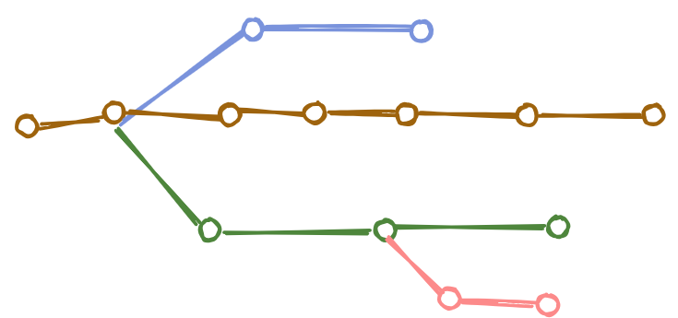

Some developers can work on Header, some can work on Footer, some can work on Content, and some can work on Layout. This is a good example of how branches can be used in git.
HEAD in git
The HEAD is a pointer to the current branch that you are working on. It points to the latest commit in the current branch. When you create a new branch, it is automatically set as the HEAD of that branch.
the default branch used to be master, but it is now called main. There is nothing special about main, it is just a convention.
Creating a new branch
To create a new branch, you can use the following command:
Terminal window
git branch
git branch bug-fix
git switch bug-fix
git log
git switch master
git switch -c dark-mode
git checkout orange-mode
Some points to note:
- git branch - This command lists all the branches in the current repository.
- git branch bug-fix - This command creates a new branch called bug-fix.
- git switch bug-fix - This command switches to the bug-fix branch.
- git log - This command shows the commit history for the current branch.
- git switch master - This command switches to the master branch.
- git switch -c dark-mode - This command creates a new branch called dark-mode. the -c flag is used to create a new branch.
- git checkout orange-mode - This command switches to the orange-mode branch.
- Commit before switching to a branch
- Go to .git folder and checkout to the HEAD file
Merging branches
Fast-forward merge
This one is easy as branch that you are trying to merge is usually ahead and there are no conflicts.
When you are done working on a branch, you can merge it back into the main branch. This is done using the following command:
Terminal window
git checkout main
git merge bug-fix

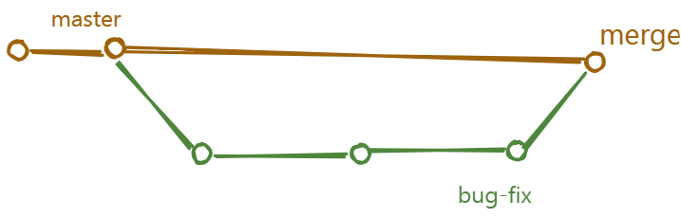

Some points to note:
- git checkout main - This command switches to the main branch.
- git merge bug-fix - This command merges the bug-fix branch into the main branch.
This is a fast-forward merge. It means that the commits in the bug-fix branch are directly merged into the main branch. This can be useful when you want to merge a branch that has already been pushed to the remote repository.
Not fast-forward merge
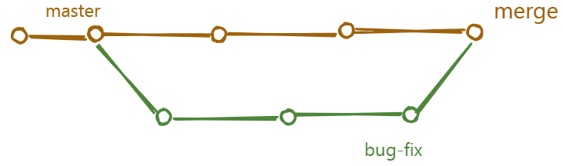

In this type of merge, the master branch also worked and have some commits that are not in the bug-fix branch. This is a not fast-forward merge.
When you are done working on a branch, you can merge it back into the main branch. This is done using the following command:
Terminal window
git checkout main
git merge bug-fix
If the command are same, what is the difference between fast-forward and not fast-forward merge?
The difference is resolving the conflicts. In a fast-forward merge, there are no conflicts. But in a not fast-forward merge, there are conflicts, and there are no shortcuts to resolve them. You have to manually resolve the conflicts. Decide, what to keep and what to discard. VSCode has a built-in merge tool that can help you resolve the conflicts.

Managing conflicts
There is no magic button to resolve conflicts. You have to manually resolve the conflicts. Decide, what to keep and what to discard. VSCode has a built-in merge tool that can help you resolve the conflicts. I personally use VSCode merge tool. Github also has a merge tool that can help you resolve the conflicts but most of the time I handle them in VSCode and it gives me all the options to resolve the conflicts.
Overall it sounds scary to beginners but it is not, it’s all about communication and understanding the code situation with your team members.
Rename a branch
You can rename a branch using the following command:
Terminal window
git branch -m <old-branch-name> <new-branch-name>
Delete a branch
You can delete a branch using the following command:
Terminal window
git branch -d <branch-name>
Checkout a branch
You can checkout a branch using the following command:
Terminal window
git checkout <branch-name>
Checkout a branch means that you are going to work on that branch. You can checkout any branch you want.
List all branches
You can list all branches using the following command:
Terminal window
git branch
List all branches means that you are going to see all the branches in your repository.
Conclusion
In this section, we have learned about the different types of merges and how to resolve conflicts. We have also learned about the importance of branching and merging in Git and Github. By the end of this section, you should have a good understanding of how to use Git and Github effectively.

Git diff
The git diff is an informative command that shows the differences between two commits. It is used to compare the changes made in one commit with the changes made in another commit. Git consider the changed versions of same file as two different files. Then it gives names to these two files and shows the differences between them.
How to read the diff
- a -> file A and b -> file B
- ---- indicates the file A
- +++ indicates the file B
- @@ indicates the line number
Here the file A and file B are the same file but different versions.
Git will show you the changes made in the file A and file B. It will also show you the line number where the change occurred along with little preview of the change.
Comparing Working Directory and Staging Area
Terminal window
git diff
This command shows the unstaged changes in your working directory compared to the staging area. This command alone will not show you the changes made in the file A and file B, you need to provide options to show the changes.
Comparing Staging Area with Repository
Terminal window
git diff --staged
This command shows the changes between your last commit and the staging area (i.e., changes that are staged and ready to be committed).
Comparing between branches
Terminal window
git diff <branch-name-one> <branch-name-two>
This command compares the difference between two branches. For example:
Another way to compare the difference between two branches is to use the following command:
Terminal window
git diff branch-name-one..branch-name-two
Comparing Specific Commits:
Terminal window
git diff <commit-hash-one> <commit-hash-two>
This command compares the difference between two commits.
Git Stash
Stash is a way to save your changes in a temporary location. It is useful when you want to make changes to a file but don’t want to commit them yet. You can then come back to the file later and apply the changes.
Conflicting changes will not allow you to switch branches without committing the changes. Another alternative is to use the git stash command to save your changes in a temporary location.
Terminal window
git stash
This command saves your changes in a temporary location. It is like a stack of changes that you can access later.
Naming the stash
You can also name the stash by using the following command:
Terminal window
git stash save "work in progress on X feature"
View the stash list
You can view the list of stashes by using the following command:
Terminal window
git stash list
Apply the stash
You can apply the stash by using the following command:
Terminal window
git stash apply
Apply the specific stash
You can apply the specific stash by using the following command:
Terminal window
git stash apply stash@{0}
Here stash@{0} is the name of the stash. You can use the git stash list command to get the name of the stash.
Applying and dropping the stash
You can apply and drop the stash by using the following command:
Terminal window
git stash pop
This command applies the stash and drops it from the stash list.
Drop the stash
You can drop the stash by using the following command:
Terminal window
git stash drop
Applying stash to a specific branch
You can apply the stash to a specific branch by using the following command:
Terminal window
git stash apply stash@{0} <branch-name>
Clearing the stash
You can clear the stash by using the following command:
Terminal window
git stash clear
Git Tags
Tags are a way to mark a specific point in your repository. They are useful when you want to remember a specific version of your code or when you want to refer to a specific commit. Tags are like sticky notes that you can attach to your commits.
Creating a tag
You can create a tag using the following command:
Terminal window
git tag <tag-name>
This command creates a new tag with the specified name. The tag will be attached to the current commit.
Create an annotated tag
You can create an annotated tag using the following command:
Terminal window
git tag -a <tag-name> -m "Release 1.0"
This command creates an annotated tag with the specified name and message. The tag will be attached to the current commit.
List all tags
You can list all tags using the following command:
Terminal window
git tag
This command lists all the tags in your repository.
Tagging a specific commit
You can tag a specific commit using the following command:
Terminal window
git tag <tag-name> <commit-hash>
Push tags to remote repository
You can push tags to a remote repository using the following command:
Terminal window
git push origin <tag-name>
Delete a tag
You can delete a tag using the following command:
Terminal window
git tag -d <tag-name>
Delete tag on remote repository
You can delete a tag on a remote repository using the following command:
Terminal window
git push origin :<tag-name>
Conclusion
In this section, we have learned about the different commands related to diff, tags and stash in git. These are not main stream commands but they are very useful in certain situations. By the end of this section, you should have a good understanding of how to use git effectively.

Rebase in git
Git rebase is a powerful Git feature used to change the base of a branch. It effectively allows you to move a branch to a new starting point, usually a different commit, by “replaying” the commits from the original base onto the new base. This can be useful for keeping a cleaner, linear project history.
Some people like to use rebase over the merge command because it allows you to keep the commit history cleaner and easier to understand. It also allows you to make changes to the code without affecting the original branch.
Merge commits
A merge commit is a commit that combines two or more commits into one. It is created when you merge two or more branches into a single branch. The merge commit contains all the changes from the original branches, and it is used to keep the project history clean and easy to understand.

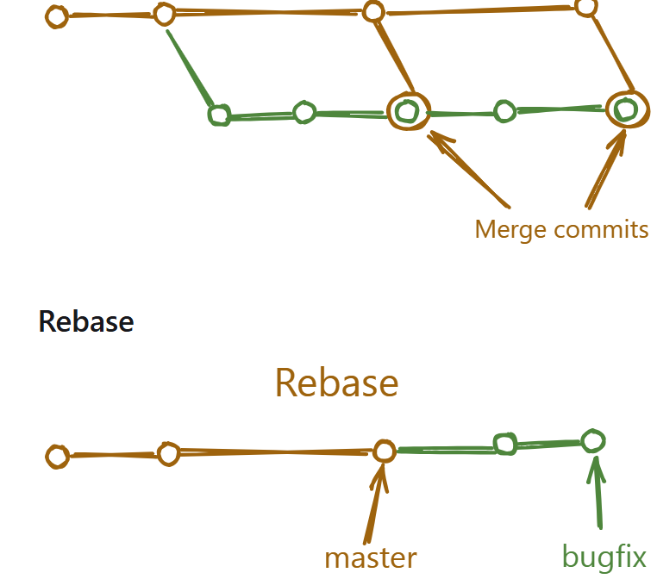
Rebase is a powerful tool in Git that allows you to move a branch to a new starting point. It effectively replays the commits from the original base onto the new base. This can be useful for keeping a cleaner, linear project history.
Here’s a flow example of using git rebase with all the commands involved:
Suppose you have a feature branch called feature-branch that you want to rebase onto the main branch.
Ensure you are on the branch you want to rebase:
Terminal window
git checkout feature-branch
git rebase main
This will replay the commits from feature-branch on top of the latest changes in main.
Resolve any conflicts:
If there are any conflicts, you will need to resolve them manually. You can use the merge tool in VSCode to resolve the conflicts.
Terminal window
git add <resolved-files>
git rebase --continue
Try to avoid —force option when using rebase. It can cause issues with the project history. I have seen many horror stories of people using —force to fix conflicts.
Git reflog
Git reflog is a command that shows you the history of your commits. It allows you to see the changes that you have made to your repository over time. This can be useful for debugging and understanding the history of your project.
View the reflog:
Terminal window
git reflog
This will show you the history of your commits. You can use the number at the end of each line to access the commit that you want to view.
Find specific commit
You can find a specific commit using the following command:
Terminal window
git reflog <commit-hash>
Recover lost commits or changes
If you accidentally deleted a branch or made changes that are no longer visible in the commit history, you can often recover them using the reflog. First, find the reference to the commit where the branch or changes existed, and then reset your branch to that reference.
Terminal window
git reflog <commit-hash>
git reset --hard <commit-hash>
or you can use HEAD@{n} to reset to the nth commit before the one you want to reset to.
Terminal window
git reflog <commit-hash>
git reset --hard HEAD@{1}
Conclusion
In this section, we have learned about the different types of merges and how to resolve conflicts. We have also learned about the importance of branching and merging in Git and Github. By the end of this section, you should have a good understanding of how to use Git and Github effectively.

What is Github?
Github is a web-based Git repository hosting service. It is a popular platform for developers to collaborate on projects and to share code. Github provides a user-friendly interface for managing and tracking changes to your code, as well as a platform for hosting and sharing your projects with others.
Some other alternative of Github are:
- Gitlab
- Bitbucket
- Azure Repos
- Gitea
But mainstream popular tool these days is Github.
Github Account
Creating a Github account is free and easy. You can create an account by visiting the Github website and clicking on the “Sign up” button. You will be prompted to enter your email address and password, and then you will be redirected to the Github homepage.
Once you have created an account, you can start using Github to host and collaborate on your projects. Github provides a variety of features and tools that make it easy to manage and track your code, including issues, pull requests, and code reviews.
Configure your config file
If you havn’t done it already, you need to configure your git config file. You can do this by running the following command:
Terminal window
git config --global user.email "your-email@example.com"
git config --global user.name "Your Name"
This will set your email and name as your global settings. You can change these settings later by running the following command:
Terminal window
git config --global user.email "your-email@example.com"
git config --global user.name "Your Name"
Now you can check your config settings:
Terminal window
git config --list
This will show you all the settings that you have changed.
Setup ssh key and add to github
If you haven’t done it already, you need to setup ssh key and add it to your github account. You can do this by following the instructions on the Github website.
You can find the exact steps on the website for both Windows and MacOS. The steps are same for both, only apple users need to add the ssh key to their keychain.
Step 1: Generate a new SSH key
To generate a new SSH key, open the terminal and run the following command:
Terminal window
ssh-keygen -t ed25519 -C "your-email@chaicode.com"
Here ed25519 is the type of key that you are generating. This creates a new SSH key, using the provided email as label.
Save the key
After generating the key, you need to save it to your computer. You can do this by running the following command:
Enter a file in which to save the key (/Users/YOU/.ssh/id_ALGORITHM): [Press enter]
At the prompt you can enter passphrase for the key or you can leave it blank. If you leave it blank, the key will be saved without a passphrase.
Add key to your ssh-agent
After saving the key, you need to add it to your ssh-agent. You can do this by running the following command:
Here it is best to refer above link for more information, as Github has a lot of information on this. There is no point in repeating it here.
Add key to github
Use the webui to add the key to your github account. You can do this by following the instructions on the Github website.
Adding code to remote repository
Now that you have setup your ssh key and added it to your github account, you can start pushing your code to the remote repository.
Create a new Repo on your system first, add some code and commit it.
Terminal window
git init
git add <files>
git commit -m "commit message"
Check remote url setting
You can check the remote url setting by running the following command:
Terminal window
git remote -v
This will show you the remote url of your repository.
Add remote repository
You can add a remote repository by running the following command:
git remote add origin <remote-url>
Here <remote-url> is the url of the remote repository that you want to add and origin is the name of the remote repository. This origin is used to refer to the remote repository in the future.
Terminal window
git remote add origin https://github.com/hiteshchoudhary/chai-something.git
Push code to remote repository
git push remote-name branch-name
Here remote-name is the name of the remote repository that you want to push to and branch-name is the name of the branch that you want to push.
Terminal window
git push origin main
Setup an upstream remote
Setting up an upstream remote is useful when you want to keep your local repository up to date with the remote repository. It allows you to fetch and merge changes from the remote repository into your local repository.
To set up an upstream remote, you can use the following command:
Terminal window
git remote add upstream <remote-url>
or you can use shorthand:
Terminal window
git remote add -u <remote-url>
You can do this at the time of pushing your code to the remote repository.
Terminal window
git push -u origin main
This will set up an upstream remote and push your code to the remote repository.
This will allow you to run future commands like git pull and git push without specifying the remote name.
Get code from remote repository
There are two ways to get code from a remote repository:
- fetch the code
- pull the code
Fetch the code means that you are going to download the code from the remote repository to your local repository. Pull the code means that you are going to download the code from the remote repository and merge it with your local repository.
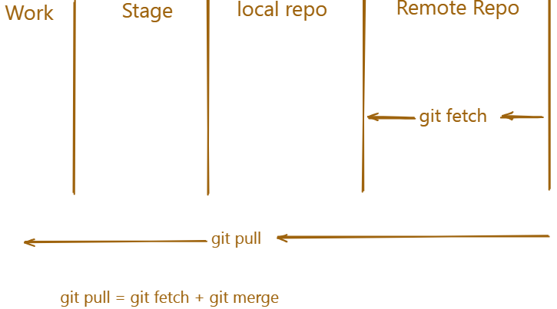

Fetch code
To fetch code from a remote repository, you can use the following command:
Terminal window
git fetch <remote-name>
Here <remote-name> is the name of the remote repository that you want to fetch from.
Pull code
To pull code from a remote repository, you can use the following command:
Terminal window
# git pull <remote-name> <branch-name>
git pull origin main
Here <remote-name> is the name of the remote repository that you want to pull from and <branch-name> is the name of the branch that you want to pull.
Conclusion
In this section, we have learned about the different types of merges and how to resolve conflicts. We have also learned about the importance of branching and merging in Git and Github. By the end of this section, you should have a good understanding of how to use Git and Github effectively.

Comprehensive List of Git Commands with Examples
Git is a distributed version control system used to track changes in code. Below is a complete list of Git commands with explanations and examples.

1. Git Configuration Commands
Check Git Version
git --version
✅ Displays the installed Git version.
Configure User Details
git config --global user.name "Your Name"
git config --global user.email "your.email@example.com"
✅ Sets your global Git username and email.
Check Current Git Configurations
git config --list
✅ Displays all the Git configurations.

2. Git Repository Commands
Initialize a New Git Repository
git init
✅ Creates a new local Git repository in the current directory.
Clone an Existing Repository
git clone https://github.com/user/repo.git
✅ Copies a remote repository to your local machine.

3. Git File Tracking Commands
Check the Status of the Repository
git status
✅ Shows the state of the working directory and staging area.
Add Files to Staging Area
git add filename.txt
git add .
✅ Adds a specific file (filename.txt) or all files (.) to the staging area.
Commit Changes
git commit -m "Initial commit"
✅ Saves the changes to the local repository with a message.

4. Git Branching Commands
List All Branches
git branch
✅ Shows all branches in the repository.
Create a New Branch
git branch feature-branch
✅ Creates a new branch named feature-branch.
Switch to a Branch
git checkout feature-branch
# OR (Recommended)
git switch feature-branch
✅ Moves to feature-branch.
Create and Switch to a New Branch
git checkout -b new-branch
# OR
git switch -c new-branch
✅ Creates a new branch and switches to it.
Merge a Branch into Main
git checkout main
git merge feature-branch
✅ Merges feature-branch into main.
Delete a Branch
git branch -d feature-branch
✅ Deletes the branch locally.

5. Git Remote Repository Commands
Add a Remote Repository
git remote add origin https://github.com/user/repo.git
✅ Links your local repository to a remote one.
View Remote Repository
git remote -v
✅ Lists the remote URLs associated with the repository.
Push Changes to Remote Repository
git push origin main
✅ Pushes local commits to the remote main branch.
Pull Latest Changes from Remote Repository
git pull origin main
✅ Fetches and merges remote changes into main.

6. Git Undo & Reset Commands
Undo Last Commit (Keep Changes)
git reset --soft HEAD~1
✅ Moves the last commit back to the staging area.
Undo Last Commit (Remove Changes)
git reset --hard HEAD~1
✅ Deletes the last commit and removes changes.
git reset filename.txt
✅ Removes filename.txt from the staging area.
Revert a Commit (Keep History)
git revert <commit-hash>
✅ Creates a new commit that undoes a previous commit.

7. Git Log & History Commands
View Commit History
git log
✅ Shows commit history.
View a Compact Log
git log --oneline --graph --all
✅ Displays commits in a simple one-line format.

8. Git Stash Commands (Save Work Without Committing)
Save Current Changes Temporarily
git stash
✅ Stashes changes for later use.
View Stashed Changes
git stash list
✅ Shows all stashed changes.
Apply Stashed Changes
git stash apply
✅ Restores the latest stash.
Remove Stashed Changes
git stash drop
✅ Deletes the last stash.

9. Git Tagging Commands
Create a Tag
git tag v1.0
✅ Creates a tag v1.0 on the latest commit.
List All Tags
git tag
✅ Shows all tags in the repository.
Push Tags to Remote
git push origin --tags
✅ Uploads tags to the remote repository.

10. Git Rebase & Cherry-Pick Commands
Rebase a Branch
git checkout feature-branch
git rebase main
✅ Moves feature-branch changes on top of main.
git cherry-pick <commit-hash>
✅ Applies a single commit from another branch.

11. Git Ignore & Cleanup Commands
Ignore Files Using .gitignore
- Create a .gitignore file.
- Add the files or directories you want to ignore:
node_modules/
- Save and commit it.
Remove Untracked Files
git clean -f
✅ Deletes untracked files from the working directory.

12. Git Collaboration & Forking
Fork a Repository (GitHub UI)
- Open the repository on GitHub.
- Click the Fork button.
Sync Fork with the Original Repository
it remote add upstream https://github.com/original/repo.git
git fetch upstream
git merge upstream/main
🛠️ Git Hands-on Guide: Real-World Workflow
🔹 Prerequisites
Before starting, make sure you have: ✅ Git installed (git --version)
✅ GitHub account (if pushing to remote)

🔹 1. Setup Git & Configure User
Run these commands to set up Git on your machine:
git config --global user.name "Your Name"
git config --global user.email "your.email@example.com"
🔹 This will identify your commits with your name and email.
Check Configuration
git config --list
🔹 This displays all your Git settings.
🔹 2. Initialize a Git Repository
Start a New Project
mkdir my_project
cd my_project
git init
🔹 This initializes a new Git repository in the my_project directory.
🔹 3. Add & Commit Files
Create a File and Add Content
echo "Hello, Git!" > hello.txt
Check Repository Status
git status
🔹 This shows untracked files (new files not added to Git yet).
Add File to Staging
git add hello.txt
🔹 Moves hello.txt to the staging area.
Commit Changes
git commit -m "Initial commit: Added hello.txt"
🔹 This saves the changes in Git with a message.
🔹 4. Connect to a Remote Repository
Create a Repository on GitHub
1️⃣ Go to GitHub
2️⃣ Click New repository
3️⃣ Name it my_project
4️⃣ Do NOT initialize with README (since we already have a local project)
5️⃣ Copy the repository URL
Link Local Repository to GitHub
git remote add origin https://github.com/yourusername/my_project.git
🔹 This links your local project to the GitHub repository.
Push the Local Repository to GitHub
git push -u origin main
🔹 Uploads all commits from the main branch to GitHub.

🔹 5. Work with Branches
Create a New Feature Branch
git branch feature-1
git checkout feature-1
# OR (shortcut)
git switch -c feature-1
🔹 Creates and switches to feature-1.
Make Changes & Commit
echo "New feature added!" > feature.txt
git add feature.txt
git commit -m "Added feature.txt"
🔹 Saves the new file to the feature-1 branch.
Push Feature Branch to GitHub
git push origin feature-1
🔹 Uploads the feature-1 branch to GitHub.
Merge Feature Branch into Main
1️⃣ Switch back to main
git checkout main
# OR
git switch main
2️⃣ Merge feature-1 into main
git merge feature-1
🔹 Merges feature-1 into main.
3️⃣ Push updated main to GitHub
git push origin main
4️⃣ Delete the merged branch
git branch -d feature-1
git push origin --delete feature-1
🔹 Removes feature-1 locally and remotely.
🔹 6. Collaborate with a Team
Pull Latest Changes from GitHub
Before making changes, always pull the latest updates:
git pull origin main
🔹 This ensures your local repo is up to date.
Resolve Merge Conflicts
If multiple people modify the same file, conflicts may occur:
git merge feature-branch
Git will show a conflict message. Open the file, edit manually, then:
git add conflicted_file.txt
git commit -m "Resolved merge conflict"
🔹 7. Undo Changes & Reset Commits
Undo Last Commit (Keep Changes)
git reset --soft HEAD~1
🔹 Moves the last commit back to the staging area.
Undo Last Commit (Remove Changes)
git reset --hard HEAD~1
🔹 Deletes the last commit and changes.
🔹 8. Work with Git Tags (Versioning)
Create a Tag
git tag v1.0
git tag
🔹 Tags the current commit as v1.0.
Push Tag to GitHub
git push origin --tags

🔹 9. Work with .gitignore
To ignore files like logs and secrets, create a .gitignore file:
touch .gitignore
echo "logs/" >> .gitignore
echo "*.log" >> .gitignore
Then commit it:
git add .gitignore
git commit -m "Added .gitignore"
git push origin main
🔹 This prevents specified files from being committed.
🔹 10. Stash Uncommitted Work
If you need to switch branches but don’t want to commit unfinished work:
git stash
🔹 This temporarily saves uncommitted changes.
Restore Stashed Work
git stash apply
🔹 Restores stashed changes.
🔹 11. Forking & Contributing to Open Source
Fork a Repository on GitHub
1️⃣ Go to any GitHub repository
2️⃣ Click Fork (top-right)
3️⃣ Clone your fork:
git clone https://github.com/yourusername/forked-repo.git
cd forked-repo
4️⃣ Add the original repo as upstream:
git remote add upstream https://github.com/original-owner/original-repo.git
5️⃣ Fetch & sync changes from the original repo:
git fetch upstream
git merge upstream/main
6️⃣ Make changes, commit, and push to your fork:
git push origin main
7️⃣ Open a Pull Request (PR) on GitHub to contribute!

